Platformer   
Cross Platform Development

Author: <Thomas Lamb>

# Change Log

Updates made to the document should be described below.

|  |  |  |  |
| --- | --- | --- | --- |
| Version | Author | Date of change | Description |
| 0.0.0 | AIE | 31/08/2020 | Initial Template created |
| 0.7.0 | Thomas Lamb | 20/9/2020 | Basic platforms and movement made |
| 0.8.0 | Thomas Lamb | 24/9/2020 | Created android version |
| 0.9.0 | Thomas Lamb | 28/9/2020 | Fixed Ui scaling of menus |
| 1.0.0 | Thomas Lamb | 7/10/2020 | Finished builds and removed bugs. Playable. |
| 1.0.1 | Thomas Lamb | 13/10/2020 | Tweaked documentation to meet guidelines |
|  |  |  |  |

Contents

Change Log 1

1.0 Development Environment 3

1.1 Game Engine 3

1.2 Source Control 3

2.0 Game Overview 3

2.1 Genre 3

2.2 Camera Perspective and Movement 3

2.3 Platform 3

2.4 Installation Methods 3

2.5 Technical Goals 3

2.6 Game Objects and Logic 4

3.0 Controls 4

3.1 Windows / Web 4

3.1 Android / Touch 4

4.0 Mechanics 4

4.1 Hazards 4

5.0 Graphics 4

5.1 ‘Mission’ / ‘Level’ structure 4

6.0 Level design 5

7.0 Interface 6

8.0 Progress report and feedback Meeting Minutes 11

Friday 4th September 11

Wednesday 9th September 11

Thursday 10th September 11

Friday 11th September 12

# Development Environment

## Game Engine

Proprietary/Unreal/Unity and version 2019.3.6f1 because of local hardware limitations and restrictions with admin privileges.

## Source Control

Link to GitHub repo - https://github.com/ThomasLambProgramming/CrossPlatformUnity

# Game Overview

Play as a cube and jump between moving platforms to reach the last gold platform to finish the game.

## Genre

Platformer/Puzzle

## Camera Perspective and Movement

3rd person camera perspective moves in accordance with the camera perspective with either wasd on the pc platform or joystick ui elements on the android platform, the camera can be moved left of right and up/down with limited range.

## Platform

The platforms available for this game is Android, webGL and windows, to deploy on each platform, simply open the unity project and export the build, the code is written so the game automatically switches ui and movement for each platform.

The platform concerns for development is to keep the UI for each platform scaling with the different resolutions and aspect ratios of both monitors and different android devices. To create movement that can be used by both a keyboard and touch controls.

## Installation Methods

Windows: users will have a exe installer to download, following the prompts that come up after opening the installer will have the game installed onto the users device.

Android: Users will have to download the apk and then run the apk to install the game onto their device.

WebGL: Users will follow a link to the game and all that is required is to have a browser that supports the WebGL platform such as chrome.

## Technical Goals

* Create working UI for windows and android
* Create moving platforms that can move in any direction
* Create limited camera movement
* Keep webGL build above 30fps
* Keep UI scaling correct

## Game Objects and Logic

Ui buttons, Cube player, Moving platforms, end and start platform, camera rotator.

# Controls

## 3.1 Windows / Web

Windows: Wasd movement and q/e for camera movement left/right , 1 / 2 for camera up/down, esc for pause and space for jump.

## 3.1 Android / Touch

Android: joystick for player movement, joystick for camera movement, pause and jump buttons

# Mechanics

* **Jumping**

When the player presses space or uses the jump button the player will jump in the air, the player will remain in the air for longer when the key/button is held and when the player has reached the peak of the jump the player will have extra gravity applied to make the jumping feel more solid overall and faster.

* **Moving platforms**The platforms will always move and will bounce similar to pong when colliding with other platforms to reverse the current direction until they collide again, creates infinite moving without stopping.

## Hazards

The entire floor other than platforms will cause the player to instantly fail and must restart the level.

# Graphics

Basic graphics, low poly assets, 3rd person style camera. Simple materials from unity.

## ‘Mission’ / ‘Level’ structure

There is currently one level and you have to move forward towards the golden platform which is the finish.

# Level design

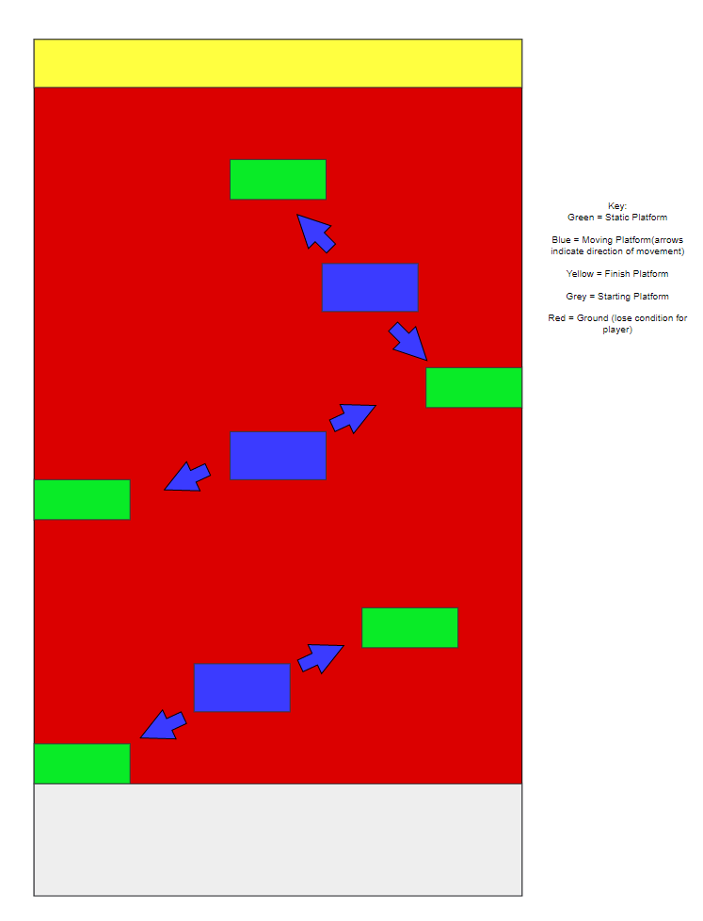

# Interface

The player on windows and android has a fail menu ui, and a pause menu ui, both of which are the same except the fail has a retry button and the pause has a continue button. (they are placed in the same position on the screen) both menus have a exit game and a return to main menu screen

Android has its own main game ui with 2 joysticks on either side for the moving of the player and the camera, there is a jump button in the middle bottom of the screen for jumping and has a pause menu button in the top left of the screen.

The main menu has an exit game button and a play game button

The finish menu has a you win text, a main menu button and an exit game button.

Wireframe of the UI implemented.

Android Main Game UI:

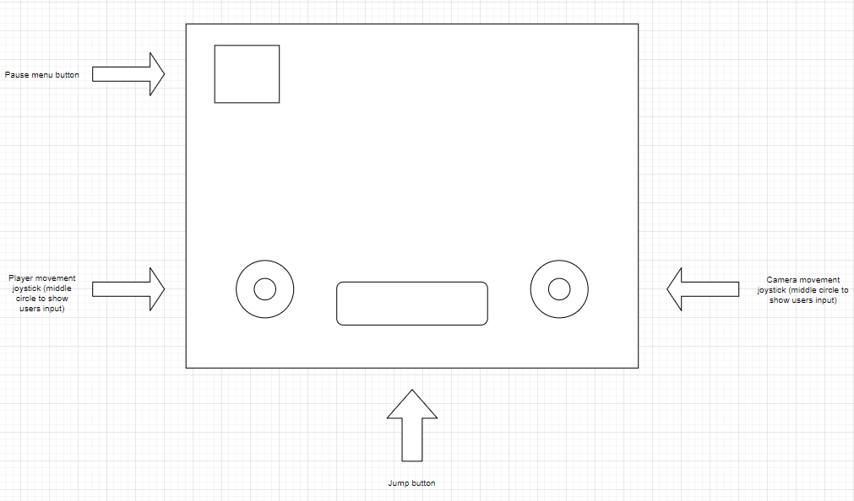

Pause menu:

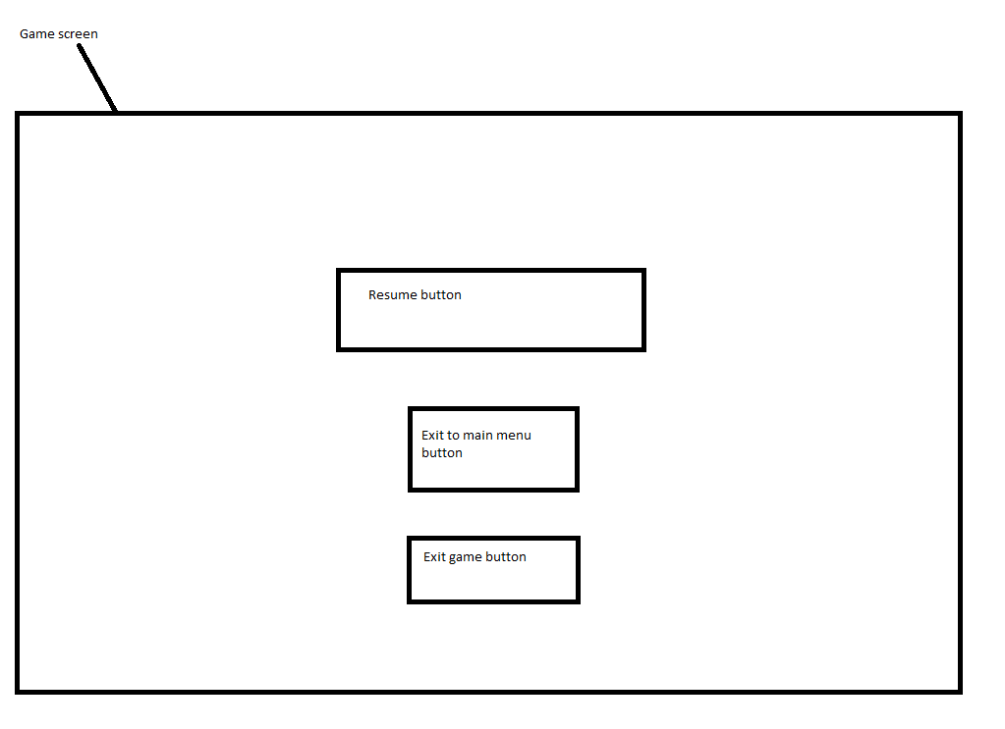

Fail Menu: 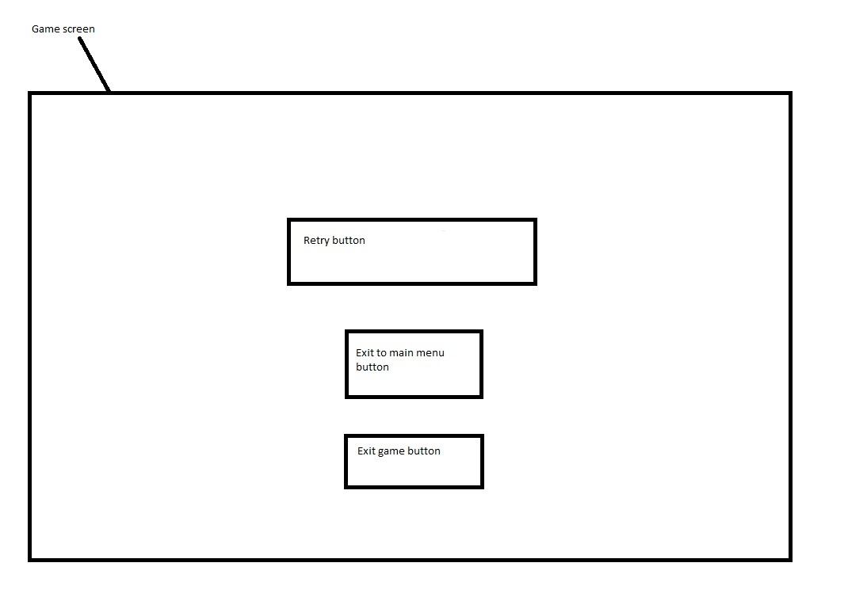

Main menu:

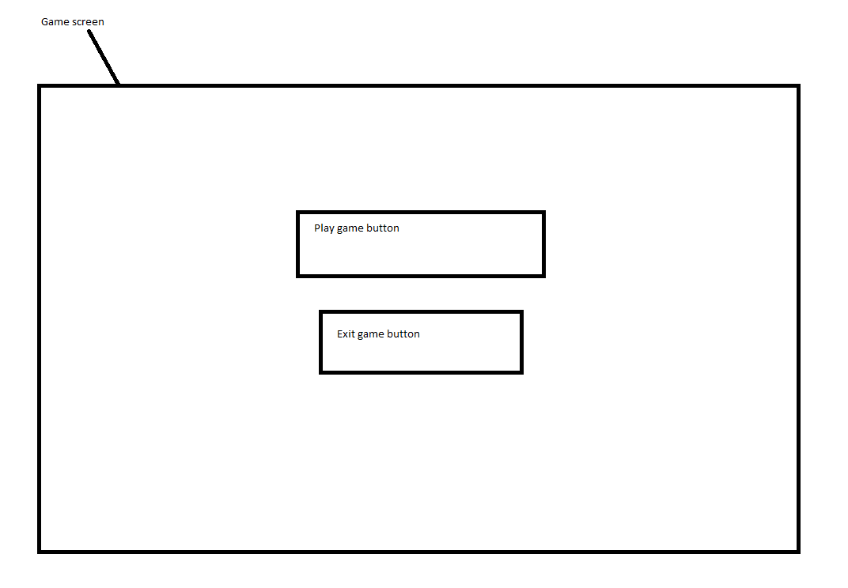

Winning Screen:

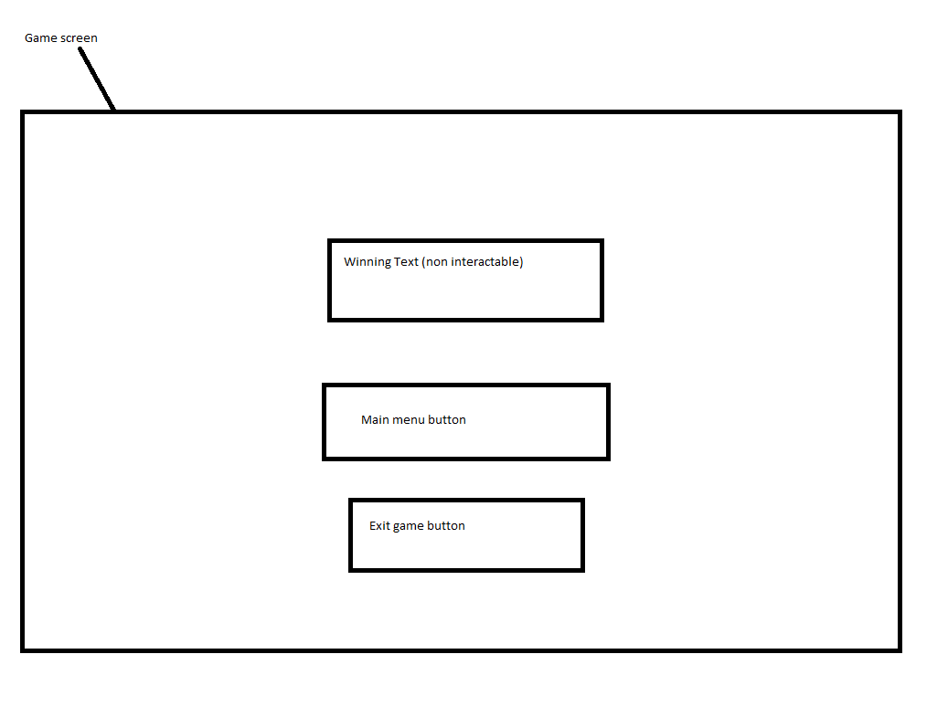

# Progress report and feedback Meeting Minutes

## Friday 4th September

Describe state of project

* Non Playable

Feedback from teacher and peers:

* Create something that is playable with movement or basic outline

Action Items:

* Create Movement
* Make UI

## Wednesday 9th September

Describe state of project

* Playable with basic scene

Feedback from teacher and peers:

* Better Movement
* Fix collisions with walls

Action Items:

* Change how collisions are detected
* Change movement

## Thursday 10th September

Describe state of project

* Playable with better collisions and movement

Feedback from teacher and peers:

* Make a more detailed level
* Add more platforms / obstacles

Action Items:

* Create moving platforms
* Make better UI which is simpler
* Build android version

## Friday 11th September

Describe what has been done since last time

* Created moving platforms.
* Made player move with them
* Added android support

Feedback from teacher and peers:

* Add a fail to the player so they have to use the platforms
* Make a winning menu

Action Items:

* Make the player be able to fail
* Bug fix small problems (glitchy collisions at certain points)
* Make webGl build and put it on the page